**Coursework 3:**

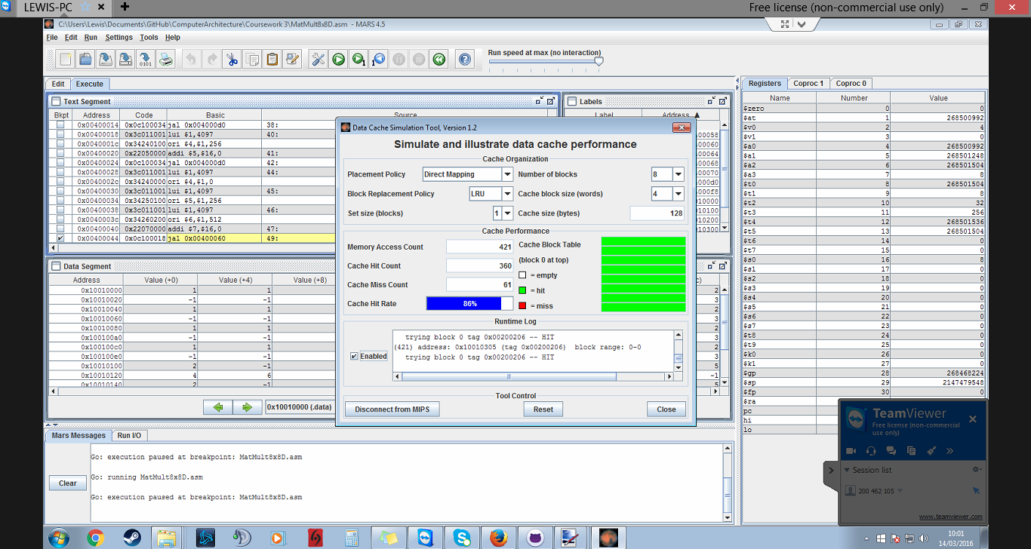First capture – up to break point of jal MatMult

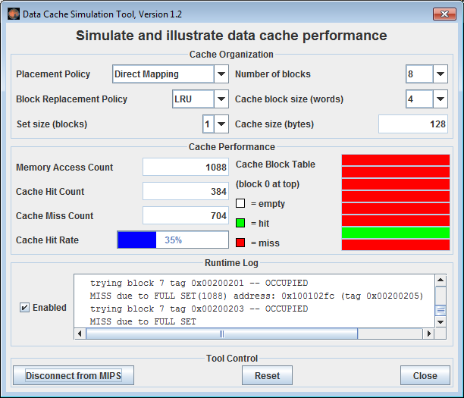from lines 49 – 51:

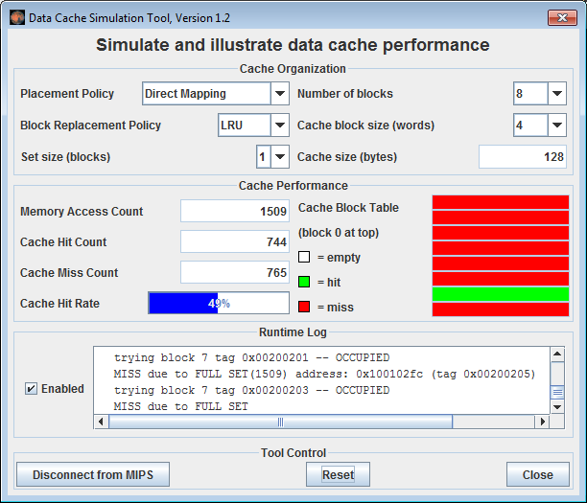From beginning to line 51: